Lab 01
NAME:NAYYAB GUL
REG NO: FA23-BAI-010
SUBJECT:COMPUTER VISION

Table 01
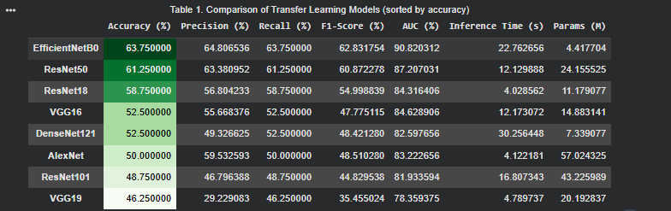
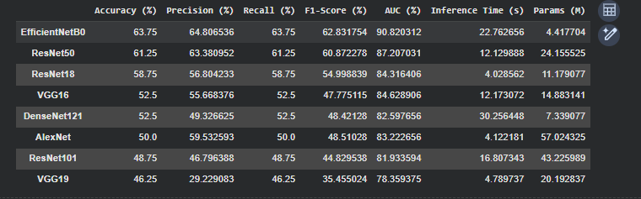
Table 02
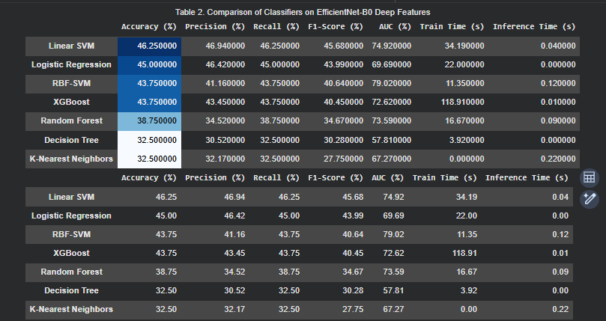
Table 03

